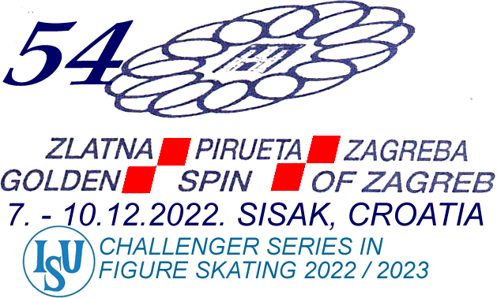

GALA PRACTICE

6,00 – 6,20 p.m. MEN, WOMEN
6,20 – 6,40 p.m. PAIRS
6,40 – 7,00 p.m. ICE DANCE

